**Exam I: A review of chapters 1 to 4**

**CIS 310 SPRING 2020**

**Please do your best to answer the following questions, using Visio or Lucid Chart.**

**1. Typically, a patient staying in a hospital receives medications that have been ordered by a particular doctor. Because the patient often receives several medications per day, there is a 1:M relationship between PATIENT and ORDER. Similarly, each order can include several medications, creating a 1:M relationship between ORDER and MEDICATION.**

1. **Identify the business rules for PATIENT, ORDER, and MEDICATION.**
   * PATIENT
     1. A patient can have many orders.
     2. Every order is for one patient.
   * ORDER
     1. Each order can include many medications.
     2. Many medications can be included on many orders.
   * MEDICATION
     1. Each order can include many medications.
     2. Many medications can be included on many orders.
2. **Create a Crow's Foot ERD that depicts a relational database model to capture these business rules.**

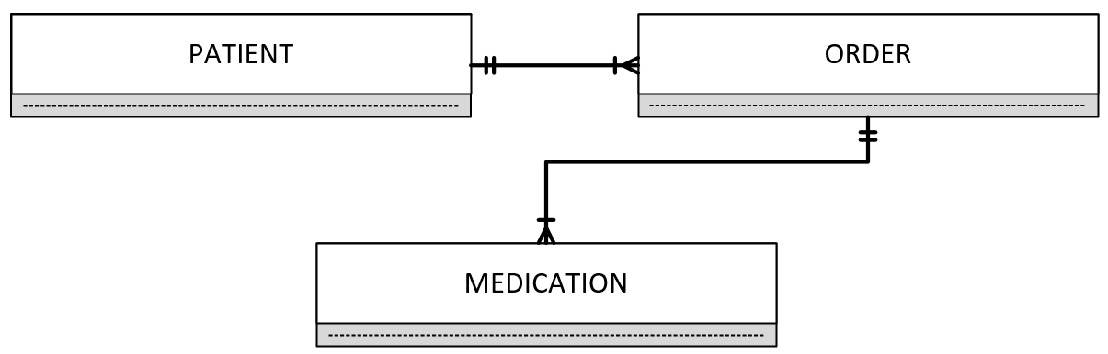

**2. United Broke Artists (UBA) is a broker for not-so-famous painters. UBA maintains a small network database to track painters, paintings, and galleries. A painting is painted by a particular artist, and that painting is exhibited in a particular gallery. A gallery can exhibit many paintings, but each painting can be exhibited in only one gallery. Similarly, a painting is painted by a single painter, but each painter can paint many paintings. Using PAINTER, PAINTING, and GALLERY, in terms of a relational database:**

1. **What entity would you create, and what would the entity components be? Identify each entity with attributes**

|  |  |  |
| --- | --- | --- |
| **Painter** | **Painting** | **Gallery** |
| PAINTER_ID  PAINTER_FNAME  PAINTER_INITIAL  PAINTER_LNAME  PAINTING_ID | PAINTING_ID  PAINTING_TITLE  PAINTING_CREATE_DATE  PAINTER_ID  GALLERY_ID | GALLERY_ID  GALLERY_NAME  GALLERY_ADDRESS  GALLER_SIZE |

1. **Identify applicable business rules for each entities**
   * Each painting is painted by only one painter.
   * A painter paints many paintings.
   * A painter can exhibit paintings at more than one gallery at a time.
   * A gallery has many paintings.
   * Each painting is in only one gallery.
2. **Show the relationships in a Crow’s Foot diagram**

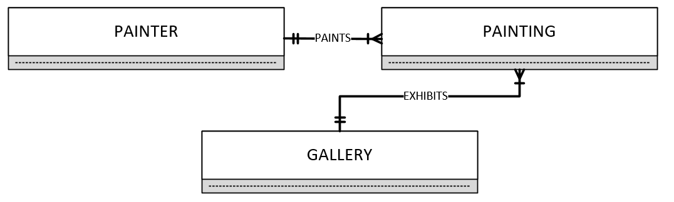

**3. Using the ERD you created from Problem 2, create the relational diagram. (Create an appropriate collection of attributes for each of the entities. Make sure you use the appropriate naming conventions to name the attributes.)**

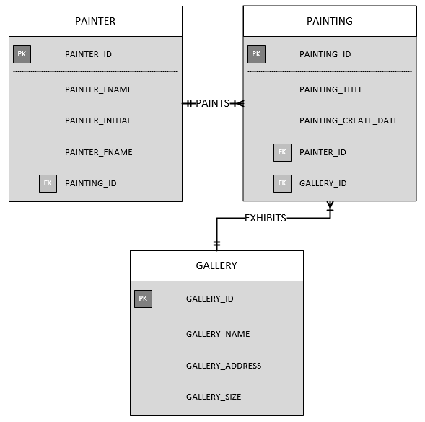

**4.** **What is the difference between a database and a table? And, why are entity integrity and referential integrity important in a database?**

* A table stores a collection of data. It is a two-dimensional structure that contains multiple rows and columns. Each row is a record, and a column is an attribute or the name of the field. A database is an organized collection of data, it can contain multiple tables. Databases make data persistent and shareable in a secure way.
* Entity integrity means all the rows in a table can be uniquely identified via the primary key of another table. This is important because it allows you to reference the rows and querying for a record will be successful. Referential integrity means every foreign key is either valid or null via the primary key of another table. This is important because it makes sure the foreign keys that are valid can be assigned as null values cannot be added to another table. This helps to prevent errors.

**5. Identify the business rules from the depicted relationships in the Crow’s Foot ERD shown in Figure below:**

* A professor teaches many classes.
* Each class is taught by one professor.
* A professor advises many students.
* Each student is advised by one professor.

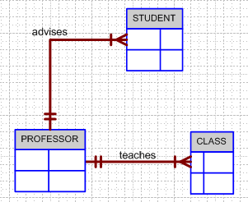

**6. Create a Crow’s Foot ERD to include the following business rules for the ProdCo company:**

1. **Each SALES REPRESENATIVE writes many INVOICES.**
2. **Each INVOICE is written by one SALES REPRESENATIVE.**
3. **Each SALES REPRESENATIVE is assigned to one DEPARTMENT.**
4. **Each DEPARTMENT has many SALES REPRESENATIVE.**
5. **Each CUSTOMER can generate many INVOICES.**
6. **Each INVOICE is generated by one CUSTOMER.**

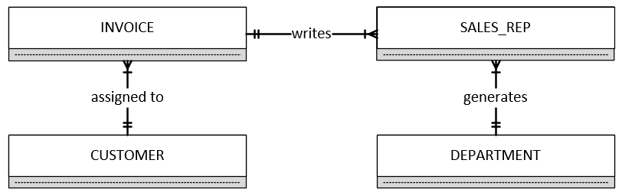

**7. Use Table 4.4 example (page 143) to create the components of the ERM and then create a Crow’s Foot ERD for each of the following descriptions.**

* 1. **Each of the MegaCo Corporation’s divisions is composed of many departments. Each of those departments has many employees assigned to it, but each employee works for only one department. Each department is managed by one employee, and each of those managers can manage only one department at a time.**

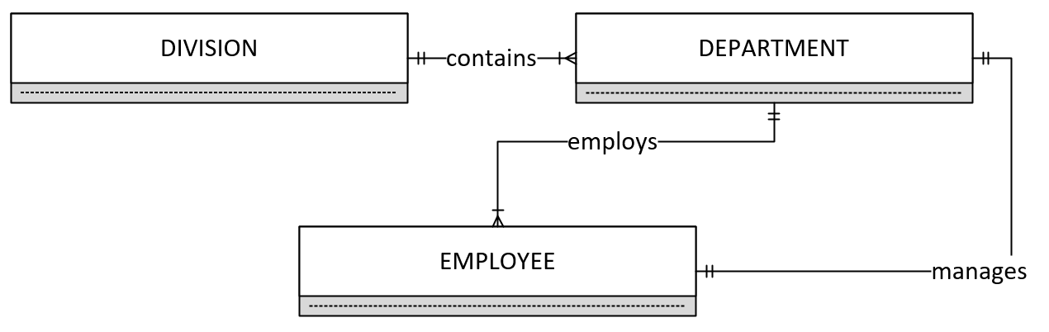

* 1. **During some period of time, a customer can download many ebooks from BooksOnline. Each of the ebooks can be downloaded by many customers during that period of time.**

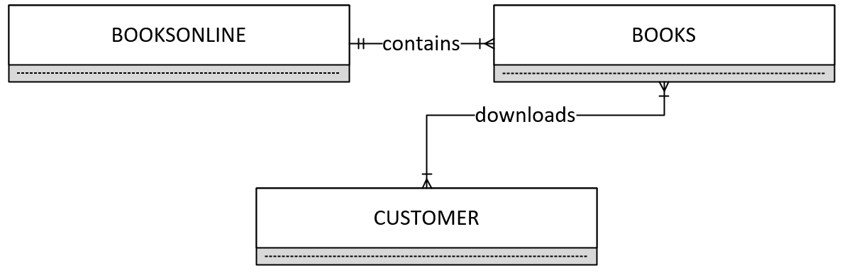

* 1. **An airliner can be assigned to fly many flights, but each flight is flown by only one airliner.**

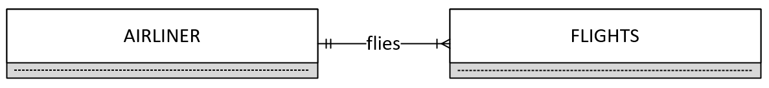

* 1. **The KwikTite Corporation operates many factories. Each factory is located in a region. Each region can be “home” to many of KwikTite’s factories. Each factory employs many employees, but each of those employees is employed by only one factory.**

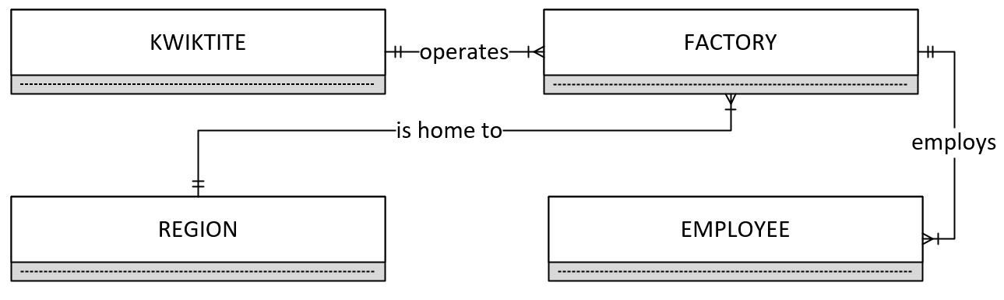

**e.** **An employee may have earned many degrees, and each degree may have been earned by many employees.**

